Exp No: 14: Determination and plotting of Polarization in different Dielectric Medium with their relative permittivity and to find electric susceptibility.
Date:
Aim:
To determine and plot polarization in different dielectric medium with their relative permittivity and to find electric susceptibility.
Software required:
• SCILAB version 6.0.1
Theory:
In a dielectric material, when an electric field is applied, the molecules or atoms within the material become polarized. This means that the positive and negative charges within the atoms or molecules shift slightly, creating an internal electric dipole moment. The polarization P is defined as the dipole moment per unit volume of the material and is given by the equation:
Code:
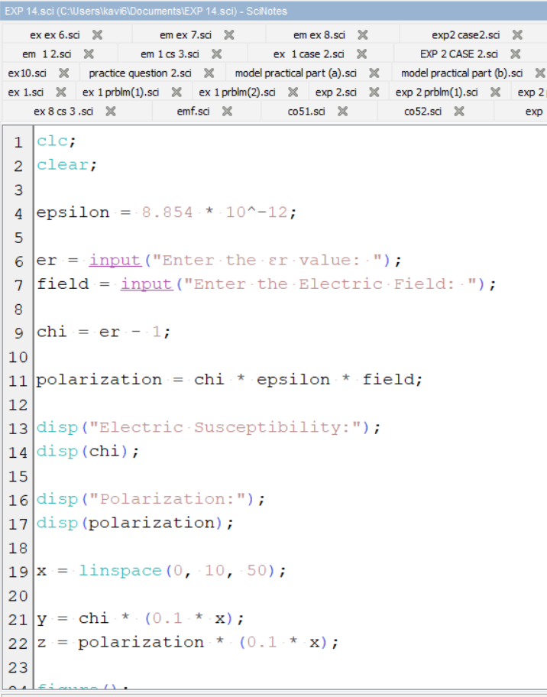

Output:
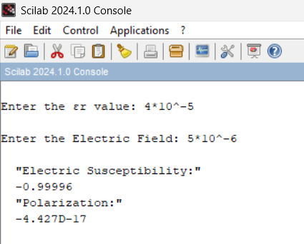
Graph:
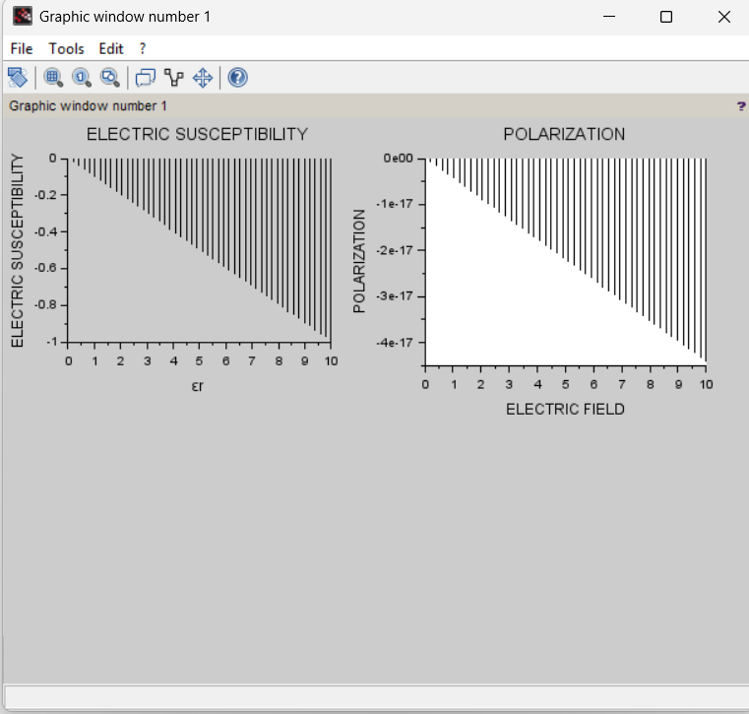
Analytical problem:
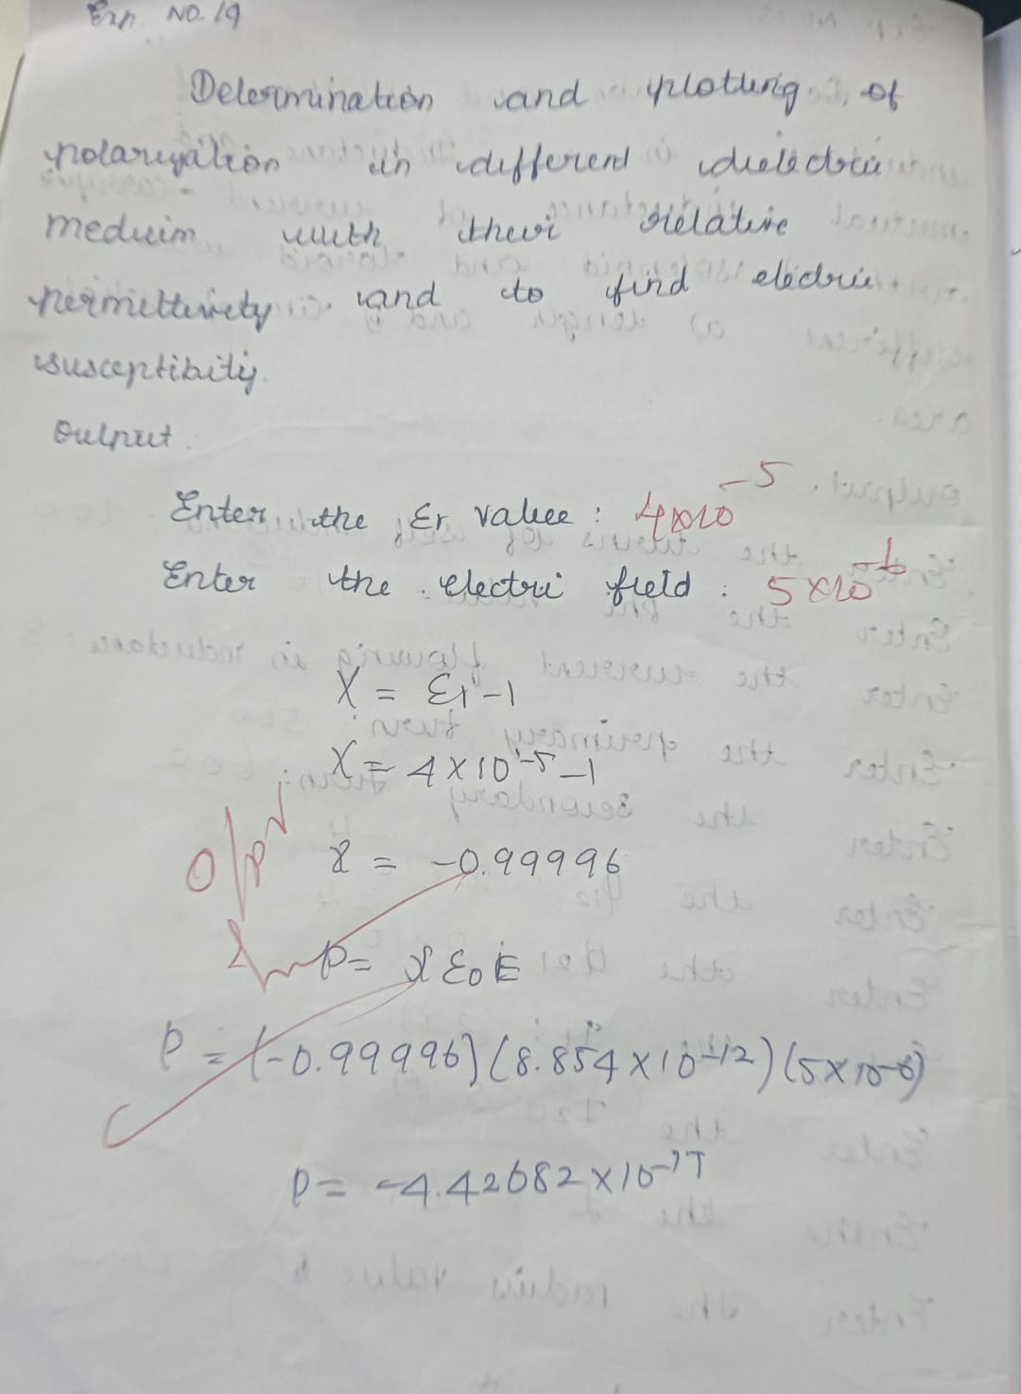

Case 1: To determine and plot the polarization and electric susceptibility of electromagnetic waves in three dielectric media: Air, Water, and Glass, using their relative permittivity.
Analytical:
Determine and plot the polarization and electric susceptibility of electromagnetic waves in three dielectric media: Air, Water, and Glass, using their relative permittivity.
- Air:
  - Relative Permittivity: ϵr=1
  - Electric Susceptibility: χe​ (to be calculated)
- Water:
  - Relative Permittivity: ϵr=80
  - Electric Susceptibility: χe
- Glass (e.g., Borosilicate Glass):
  - Relative Permittivity: ϵr=6
  - Electric Susceptibility: χe
Code:
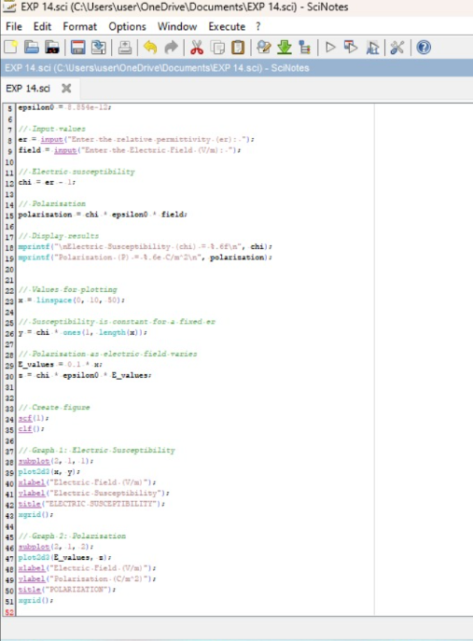
Output:
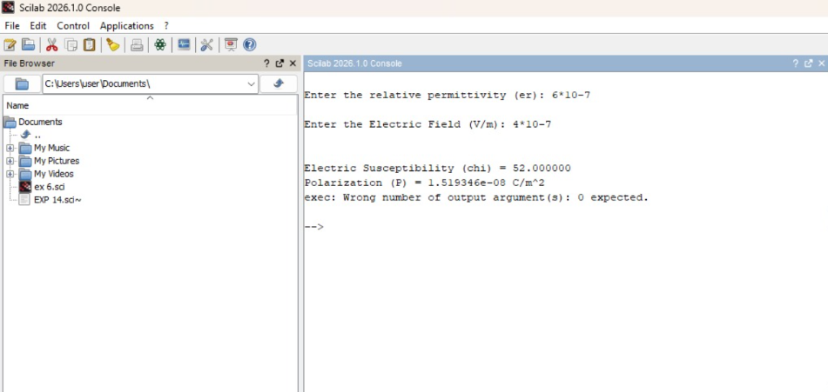
Graph:
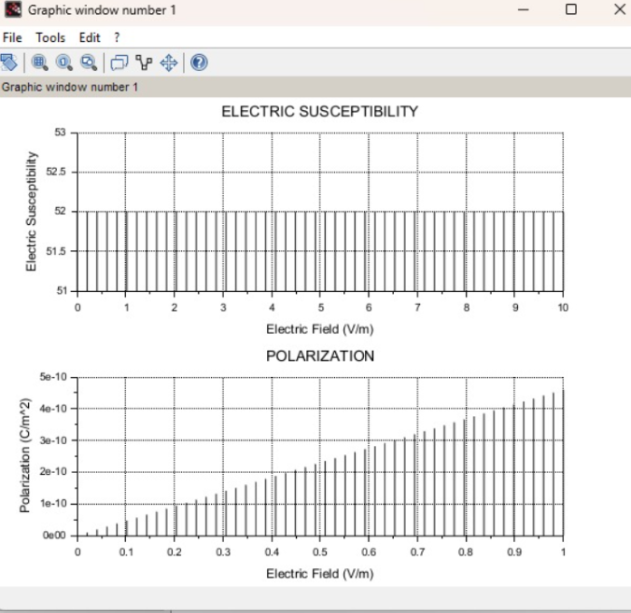
Case 2: To calculate and plot the polarization and electric susceptibility in Silicon, Teflon, and Paper, and understand how their relative permittivity affects the polarization.
Analytical:
To calculate and plot the polarization and electric susceptibility in Silicon, Teflon, and Paper
- Silicon:
  - Relative Permittivity: ϵr=11.7
  - Electric Susceptibility: χe​
- Teflon:
  - Relative Permittivity: ϵr=2.1
  - Electric Susceptibility: χe​
- Paper:
  - Relative Permittivity: ϵr=3.0
  - Electric Susceptibility: χe​
Code:

Output:
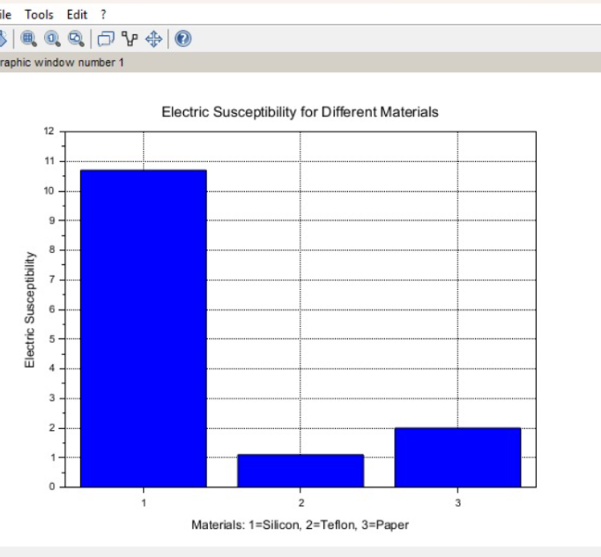

Case 3: To explore how different dielectric materials (Rubber, Oil, and Plastic) affect the polarization and electric susceptibility, and to compare their relative permittivity’s.
Analytical:
Calculate how different dielectric materials (Rubber, Oil, and Plastic) affect the polarization and electric susceptibility, and to compare their relative permittivity’s.
- Rubber:
  - Relative Permittivity: ϵr=3.5
  - Electric Susceptibility: χe
- Oil:
  - Relative Permittivity: ϵr=2.2
  - Electric Susceptibility: χe​
- Plastic (e.g., Polyethylene):
  - Relative Permittivity: ϵr=2.3
  - Electric Susceptibility: χe​
Code:


Output:
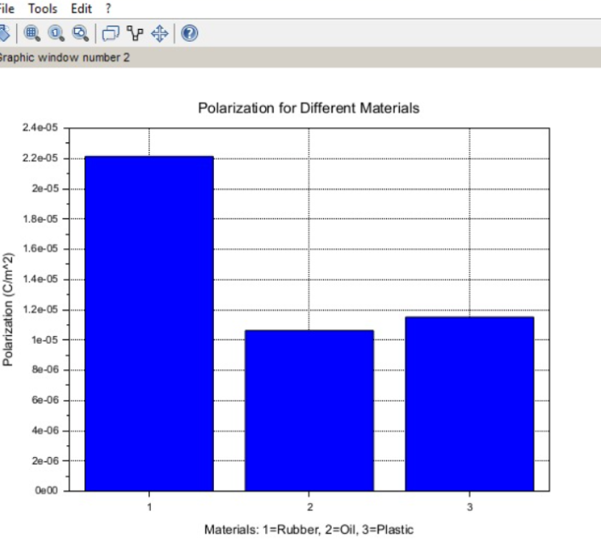

Case 3: To examine how the magnetic flux density (B) in a ferromagnetic material changes with different values of magnetic field intensity at constant length and width.
Conditions:
- Material: Soft iron (same as in the previous studies)
- Length (L): Constant at 10 cm
- Width (W): Constant at 5 cm
- Magnetic Field Intensity (H): Varies from 200 A/m to 2000 A/m (i.e., 200 A/m, 500 A/m, 1000 A/m, 1500 A/m, 2000 A/m)


